Report
The Career Guidance and Placement Cell and the Department of Computer Science, in association with the Internal Quality Assurance Cell (IQAC), Sir C. R. Reddy College for Women, Eluru, organized a three-day “IBM Skills Build Training Programme” in collaboration with ICT Academy.
The programme was conducted as part of the “A CSR Initiative – Adult Learner Programme 2026–27”, facilitated by IBM, on the course “Data Analytics”. The programme was organized with the objective of enhancing students’ technical knowledge, practical skills, analytical abilities, and industry readiness in the field of Data Analytics.
The training programme commenced with an inaugural ceremony attended by Ms.G.Sarala, Principal, Sir C. R. Reddy College for Women, Mr. K. V. V. Srinivas, Head of the Department of Computer Science, G. S. R. Kalyani, Placement and Training Officer, and the Resource Person, Mr. Injaparu Haribabu, who facilitated the IBM Skills Build training programme.
During the inauguration, the dignitaries addressed the students and emphasized the importance of acquiring industry-relevant technical skills and continuously upgrading their knowledge to meet the changing requirements of the IT industry. The Resource Person highlighted the growing significance of Data Analytics and its wide-ranging applications across various sectors.
The programme was organized for the final-year students of III B.Sc. Computer Science and III B.Sc. Data Science. A total of 111 students actively participated in the training programme. To facilitate effective learning, interaction, and practical engagement, the students were divided into two batches. Batch 1 consisted of 62 students and attended the training programme from 21st September to 23rd September 2026, while Batch 2 consisted of 49 students and participated from 24th September to 26th September 2026.
The three-day training programme for each batch focused on Data Analytics and provided students with an opportunity to gain industry-oriented knowledge and develop relevant technical and analytical skills. The sessions were designed to provide students with practical exposure to important concepts and applications related to Data Analytics.
The sessions were facilitated by the Resource Person, Mr.Injaparu Haribabu, who engaged the students through interactive discussions, practical demonstrations, and activity-based learning. The training enabled students to strengthen their analytical thinking and gain a better understanding of the role and importance of Data Analytics in the contemporary IT industry.
The programme was conducted as part of the institution’s continuous efforts to strengthen students’ employability and career readiness. It provided a valuable platform for the participating students to enhance their understanding of Data Analytics, develop technical and analytical skills, gain industry-oriented exposure, and understand the importance of continuous learning and up skilling in the rapidly evolving technology sector.
The training programme concluded with a valedictory ceremony concluded with a note of appreciation to the Resource Person, the organizers, faculty members, and students for their valuable contribution and active participation, making the IBM Skills Build Data Analytics Training Programme a successful and enriching learning experience.
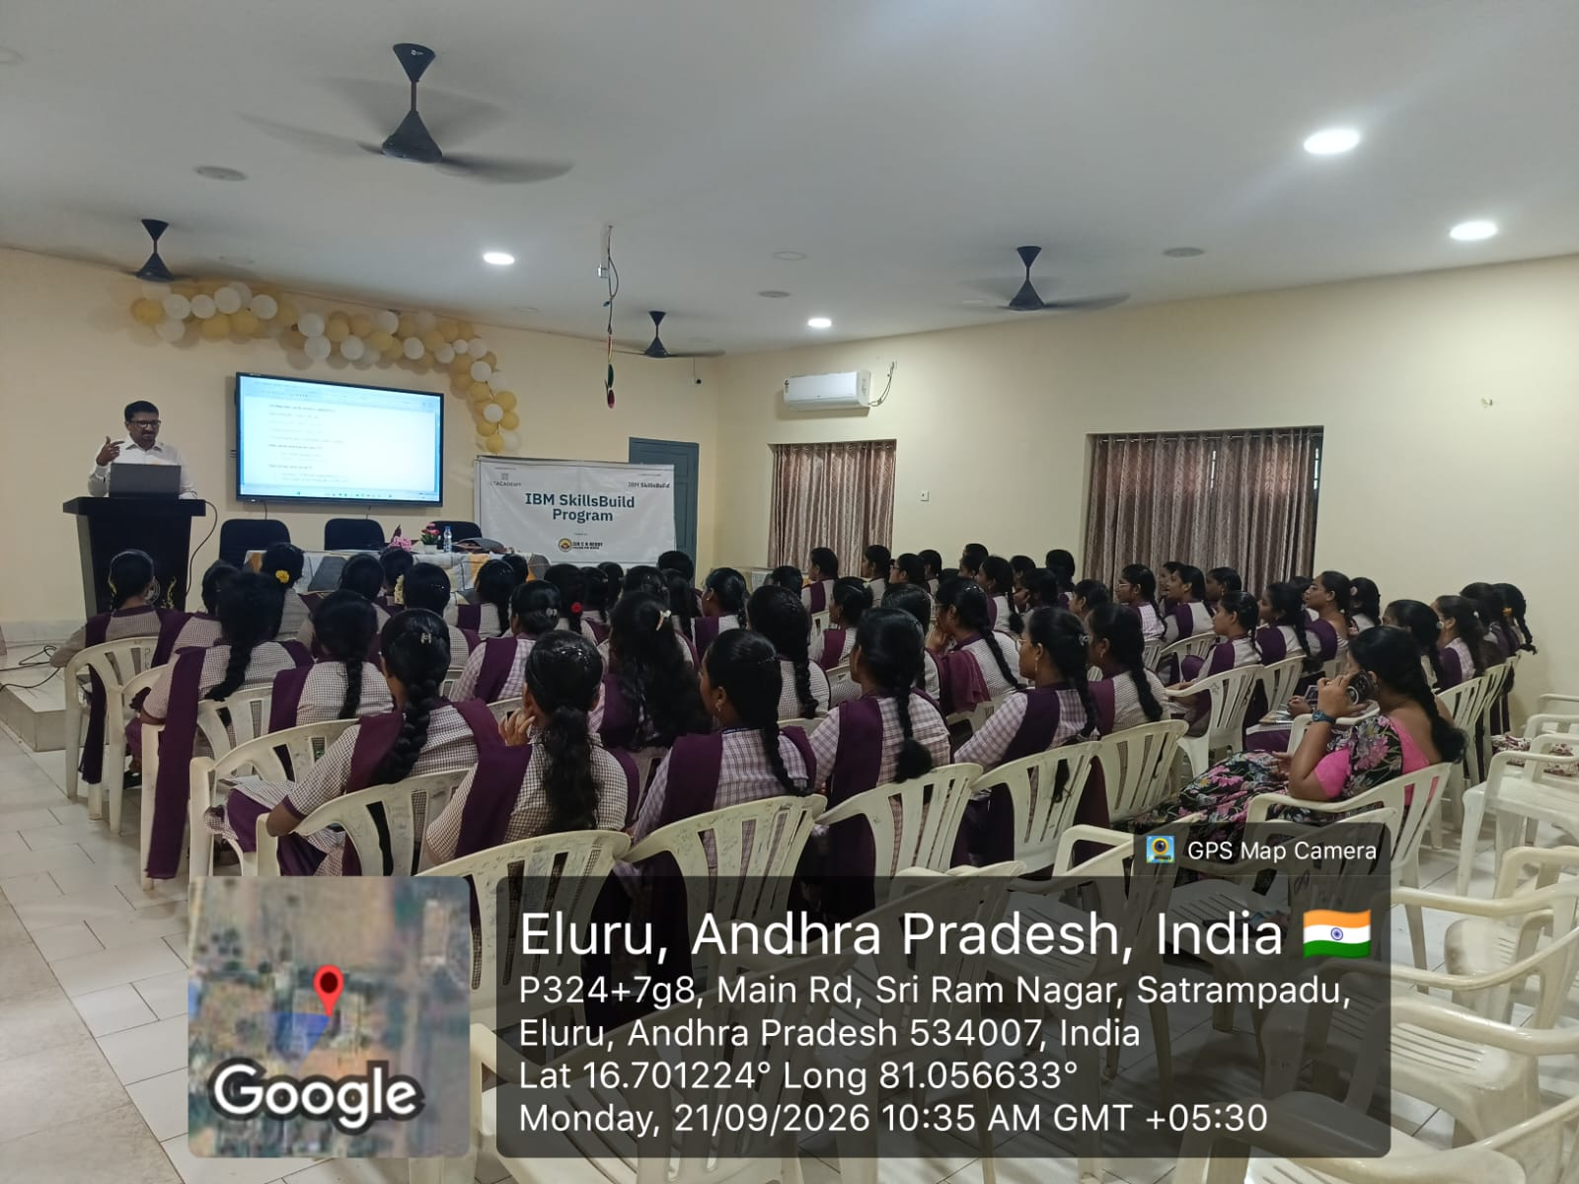
Inauguration of IBM skills Build program
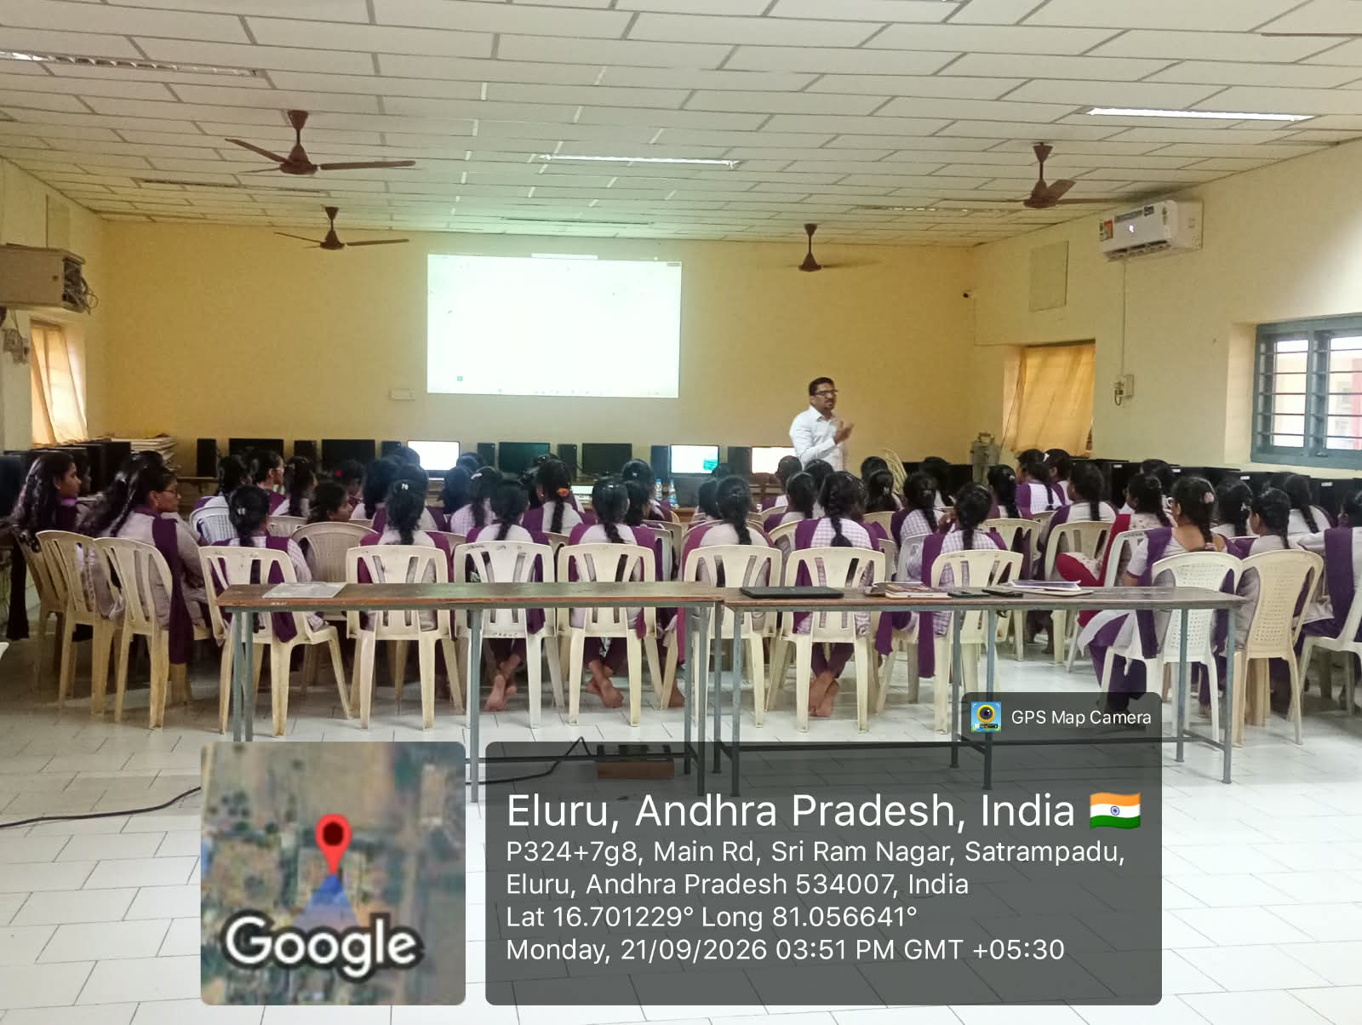
Training session for Batch 1 by Mr.Injarapu Haribabu
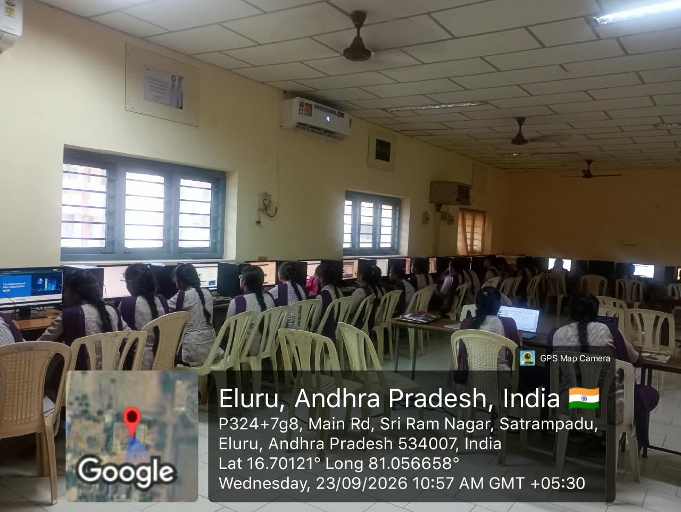Hands-on session for Batch-1
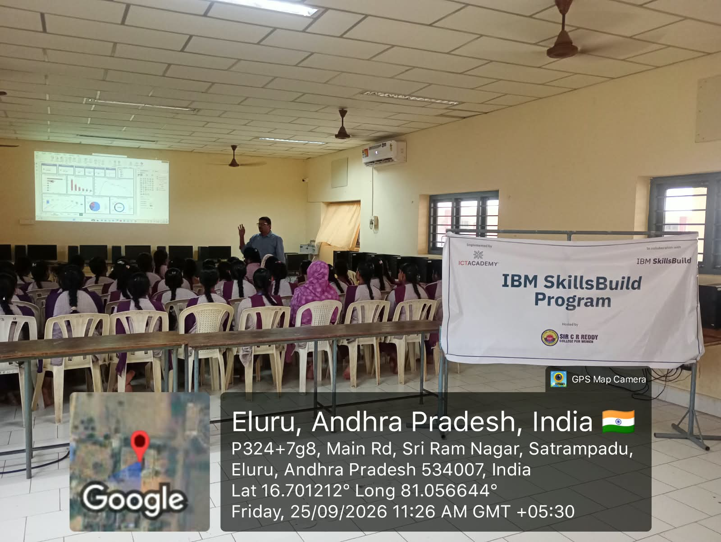
Session for Batch-2
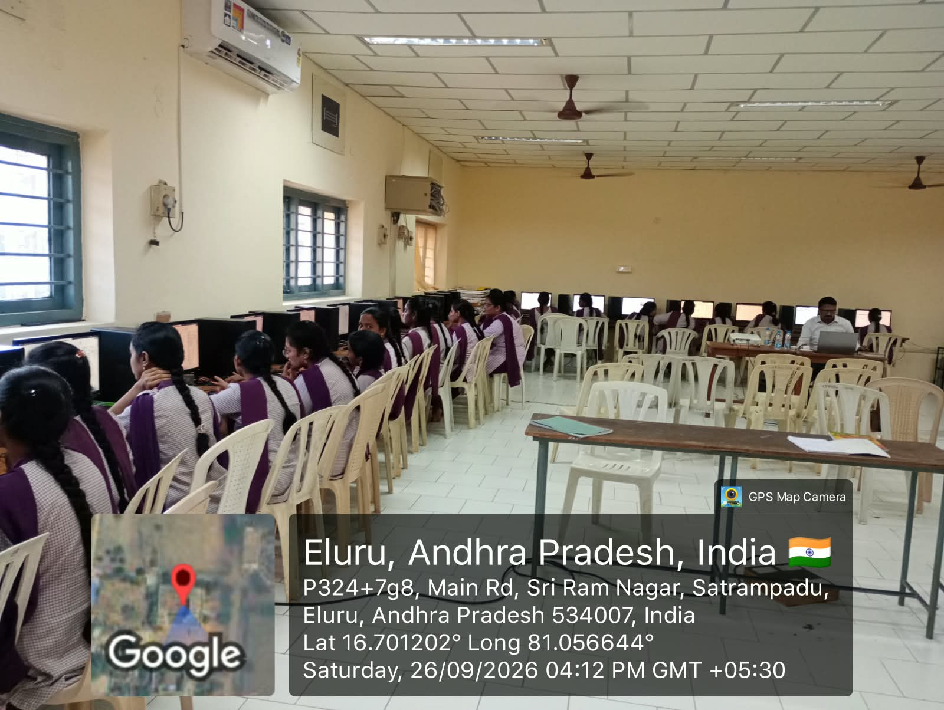Hands-on session for Batch-2
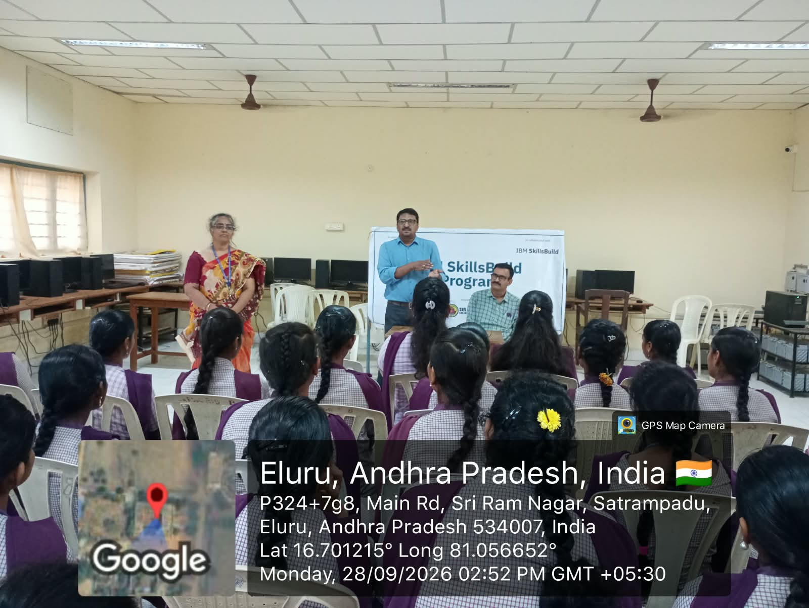
Valedictory
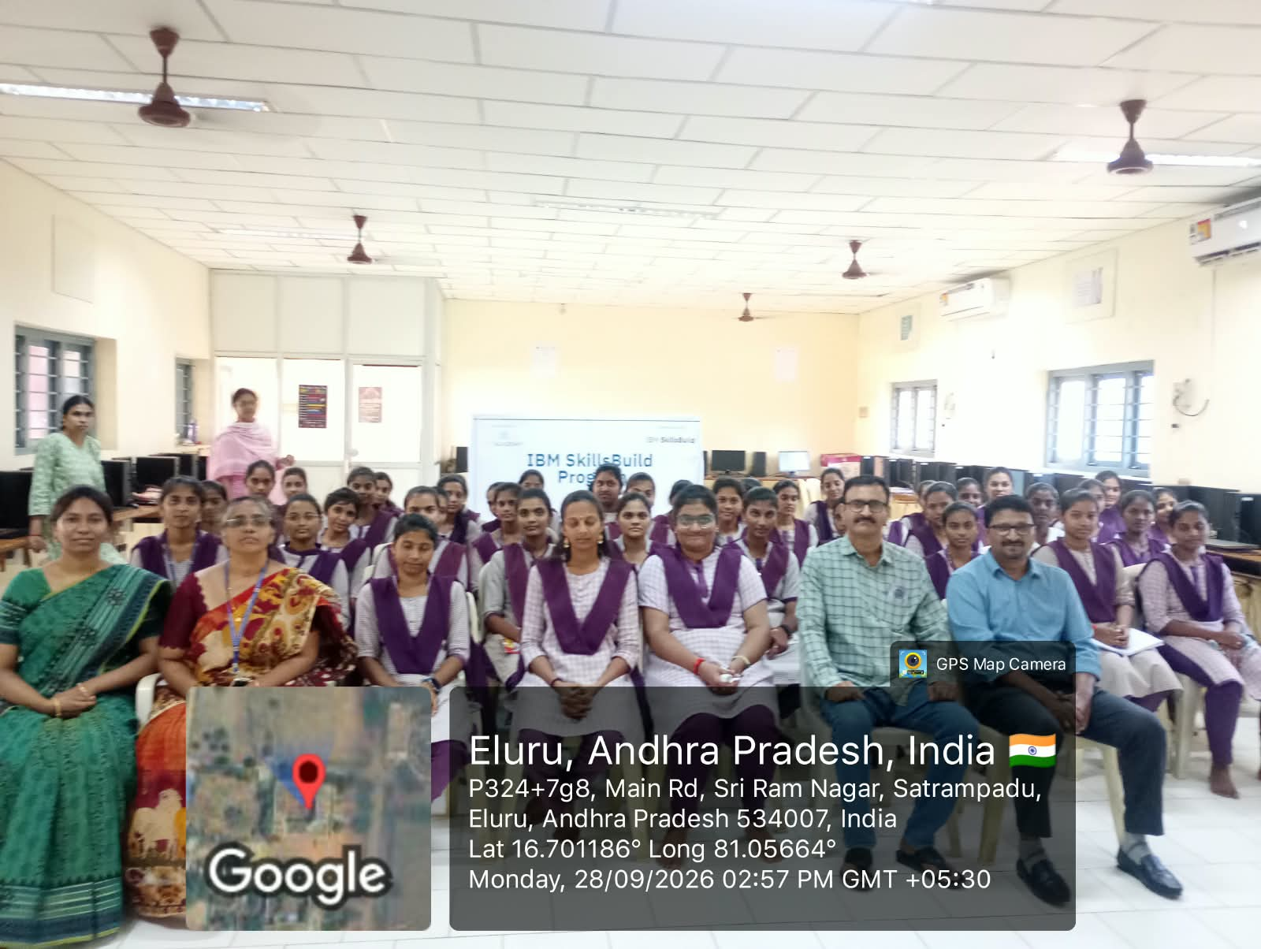
Hod kvv Srinivas, Mentors and Trainer Mr.Injarapu Haribabu in Valedictory

